Shavuot 5784
Presentation by Noah Dor Lind, rabbinic intern at Mishkan Shalom Synagogue
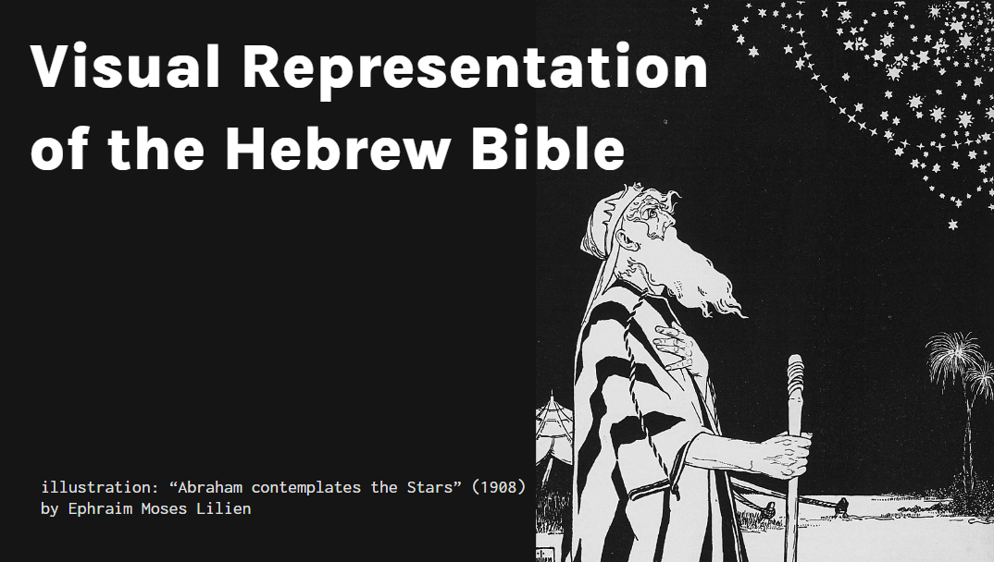
ROAD MAP
- PATHOS: Why is this important?
- HISTORY: An earnest attempt at a historical approach
- ART: Representation as interpretation
- YOUR TURN: Conclusion and activity
My first unit of Clinical Pastoral Education at Thomas Jefferson University Hospital, Summer 2022

A Pesach seder, sometime around 2010-2013

Distributed by: DreamWorks Pictures. 1998
My illustrations, created around 2008-2010
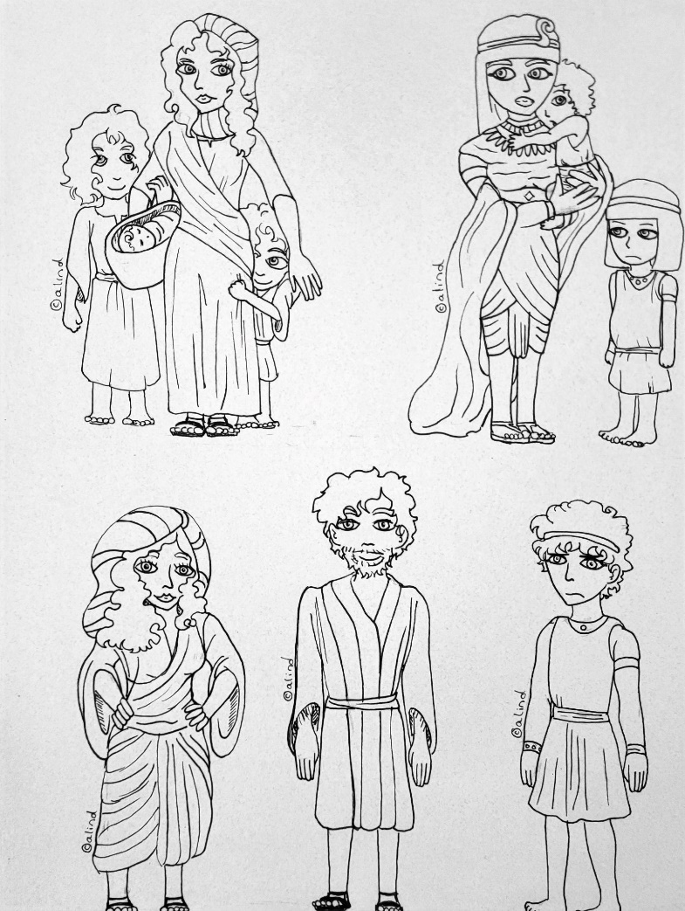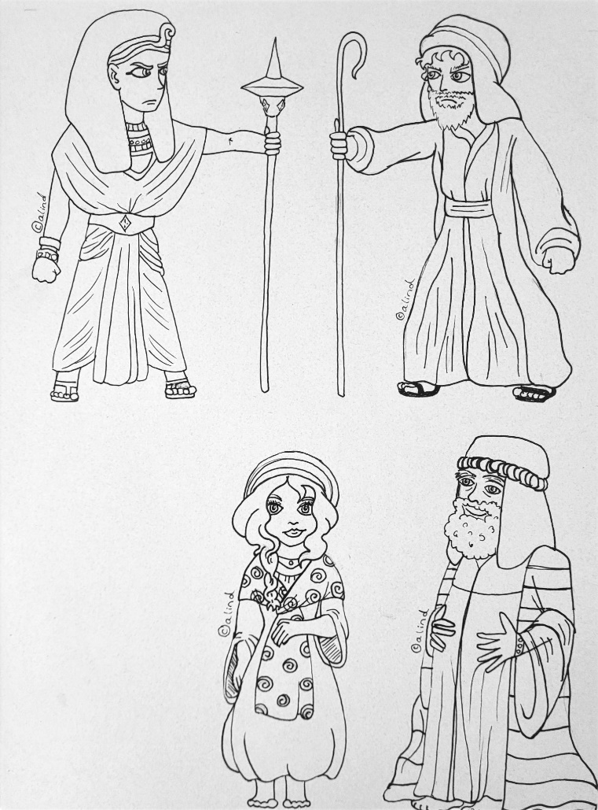
WHEN
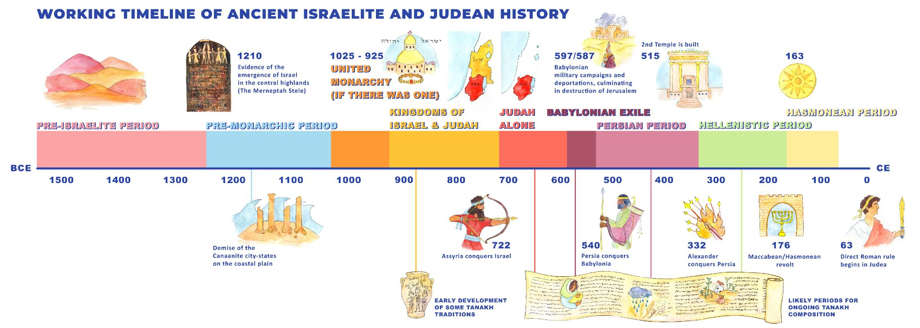
Timeline: Collaboration between Dr. Elsie Stern and Noah Dor Lind
- Compositional period is Late Iron Age
- My focus of research (1100) 10th c. B.C.E. to (300) 4th c. B.C.E.
- REAL QUESTION: What were the authors of the Bible wearing?

WHERE
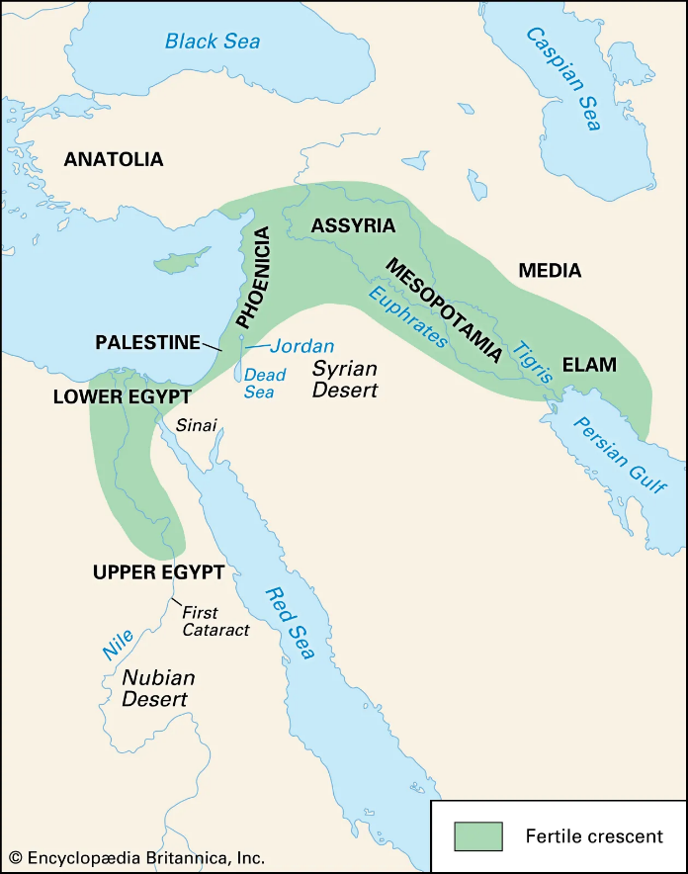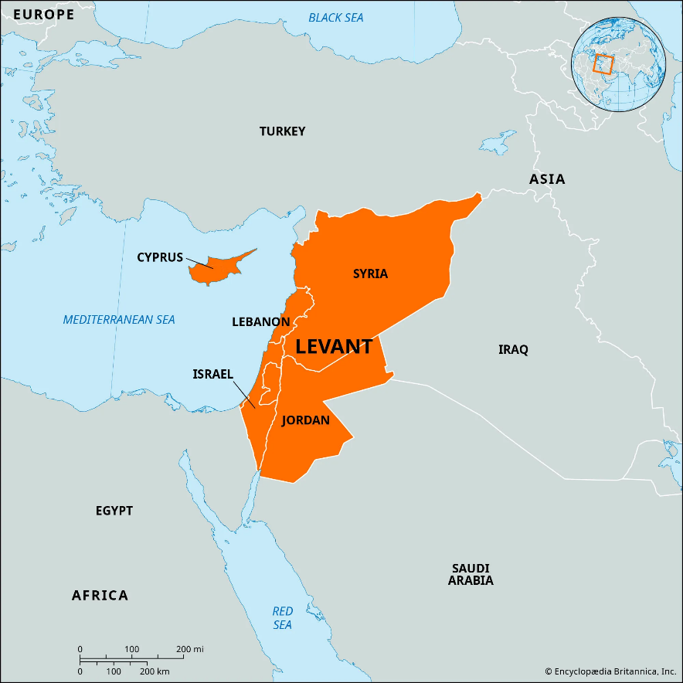

SOURCES
- The Hebrew Bible
- Archeological evidence
- Iconographic evidence
HEBREW BIBLE/ TANAKH
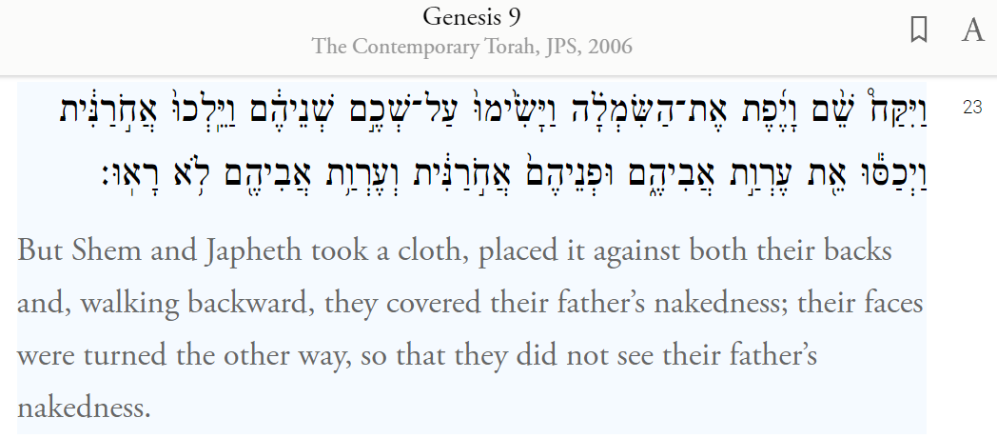
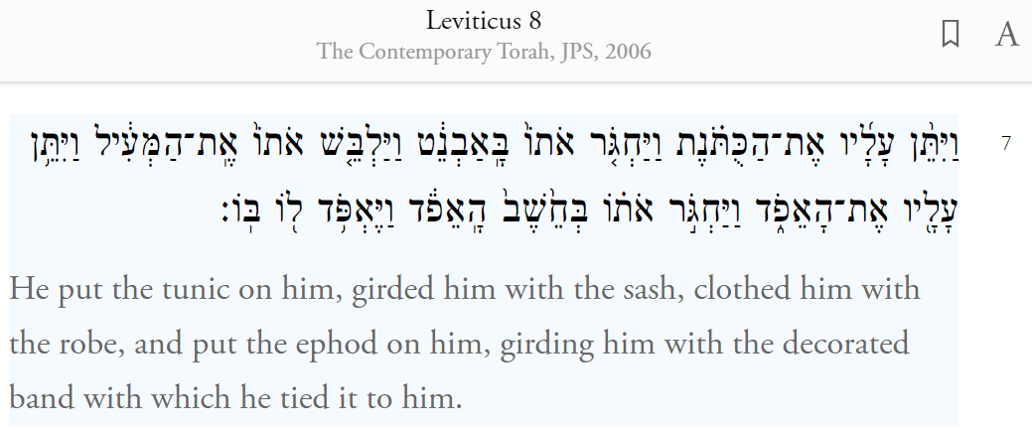
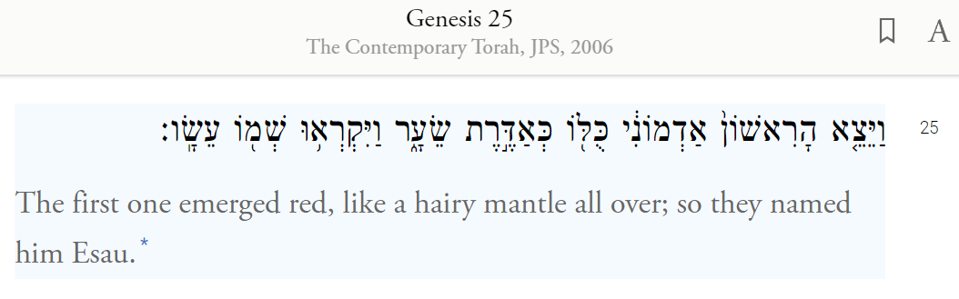

ARCHEOLOGICAL EVIDENCE
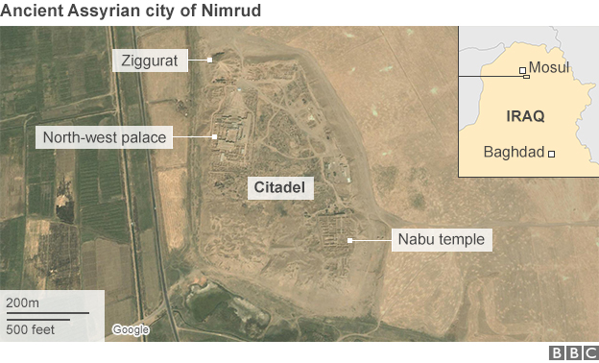
Nimrud - Queen’s Tomb II - 9th-8th c. B.C.E.
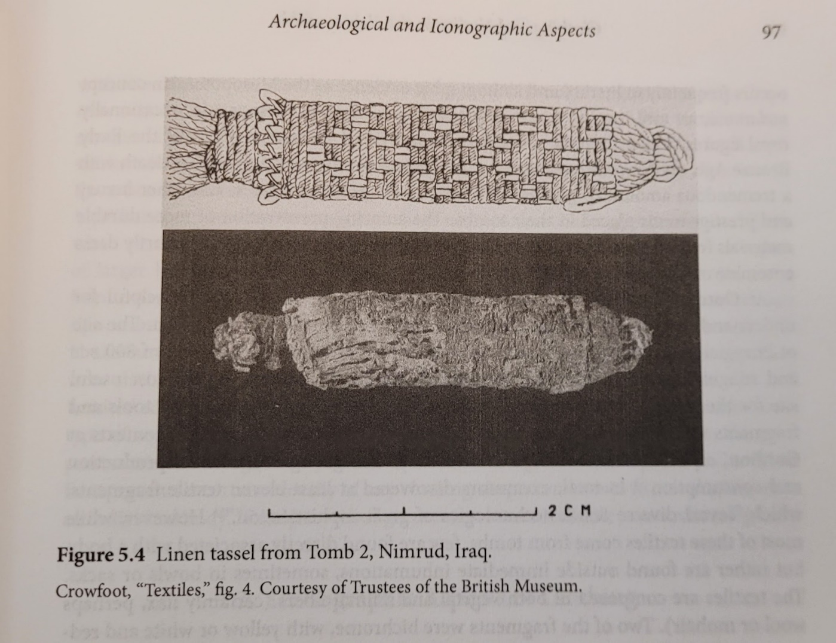

ICONOGRAPHIC EVIDENCE
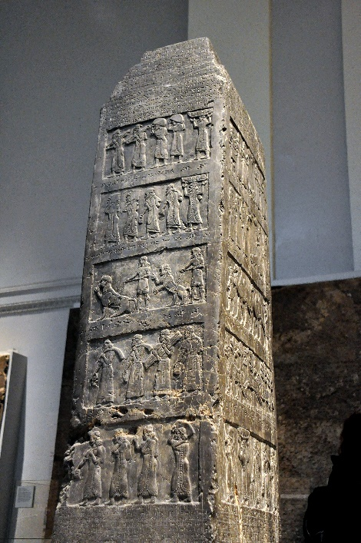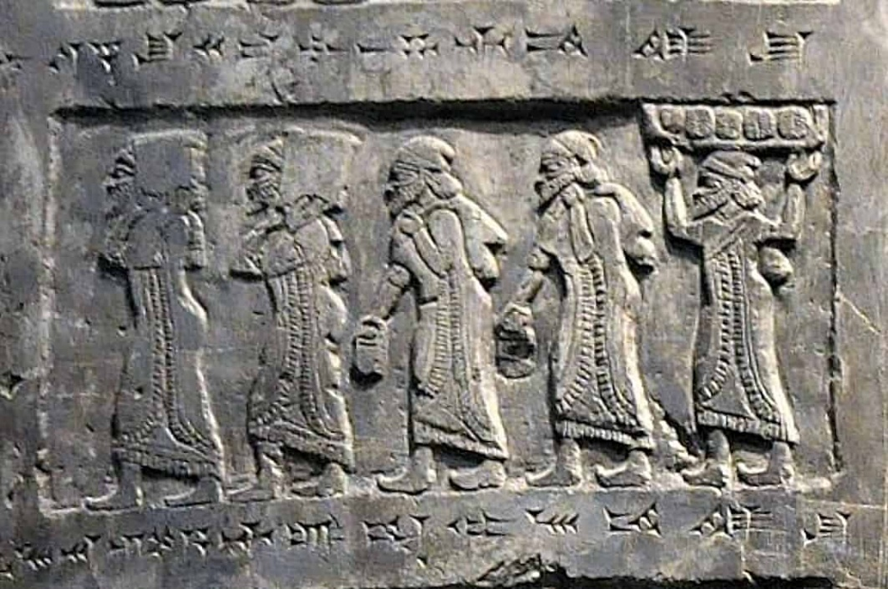
The Black Obelisk of Shalmaneser III - 827–824 BCE Lachish reliefs - 700-681 BCE
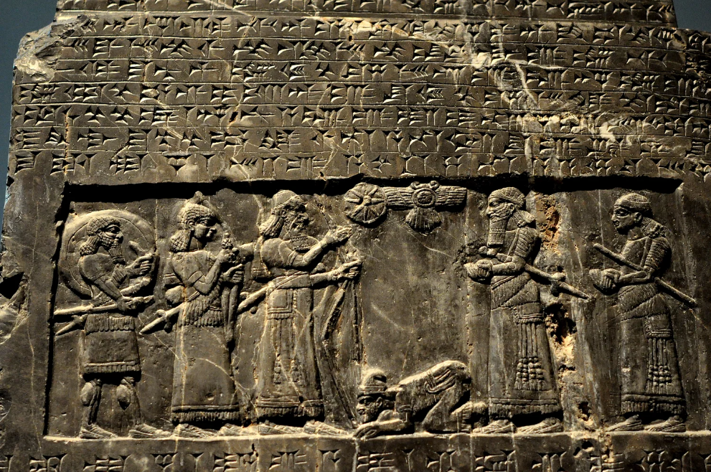
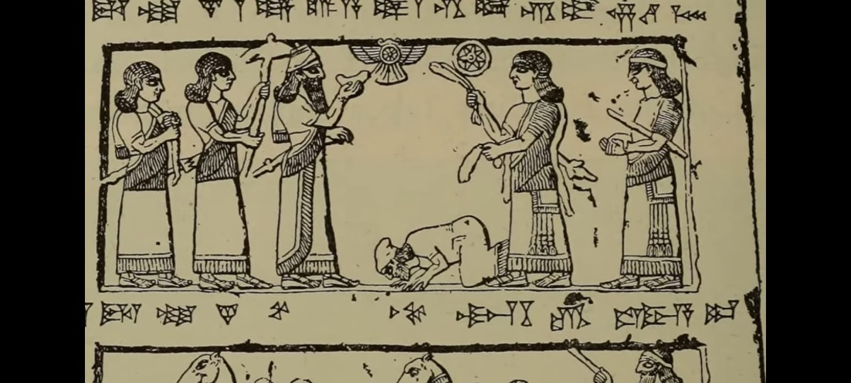

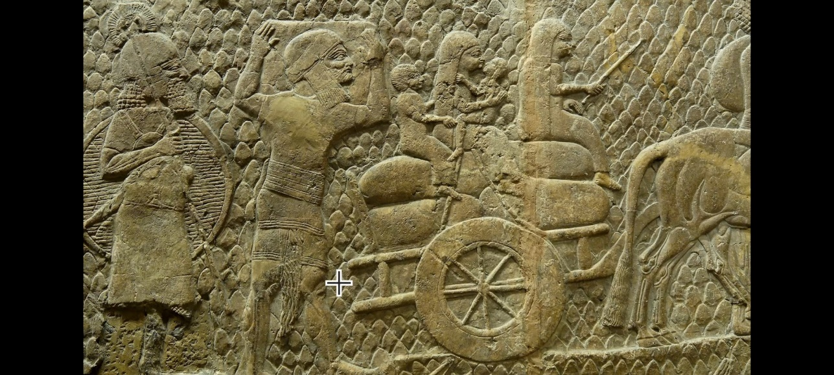
Lachish reliefs - 700-681 BCE
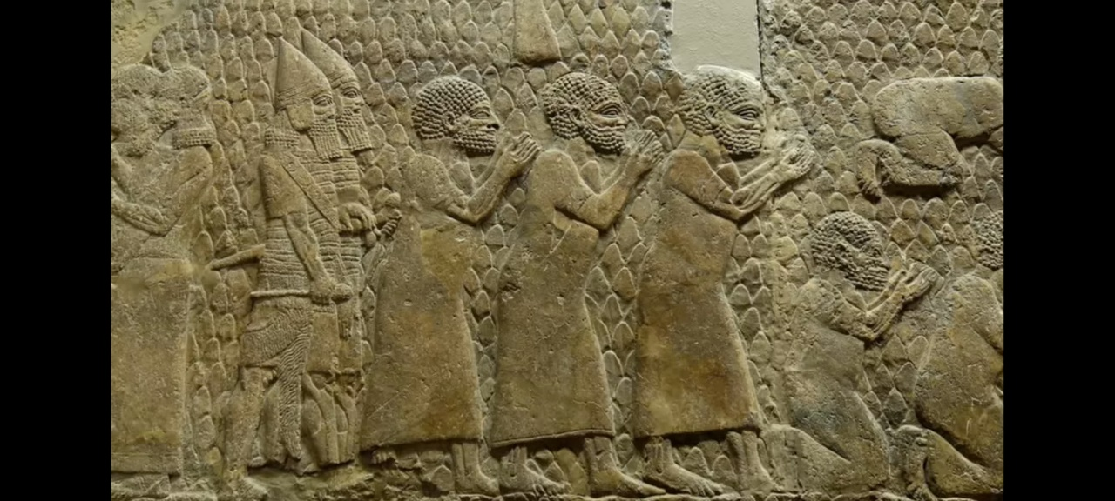
Lawrence Venuti, translation theorist/historian: Two tendencies of translators (1995)
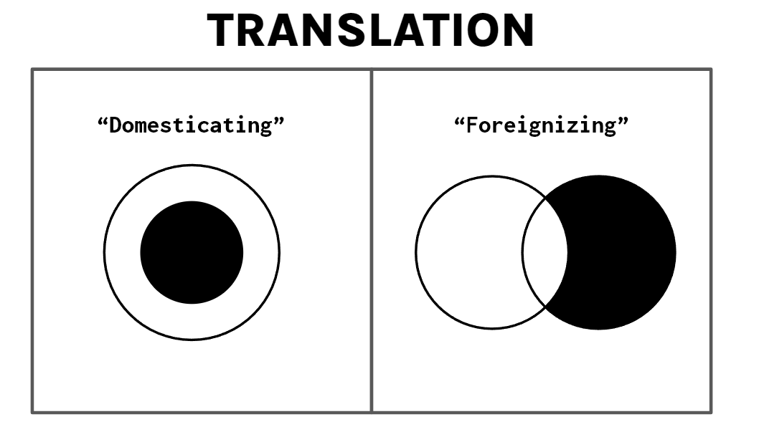
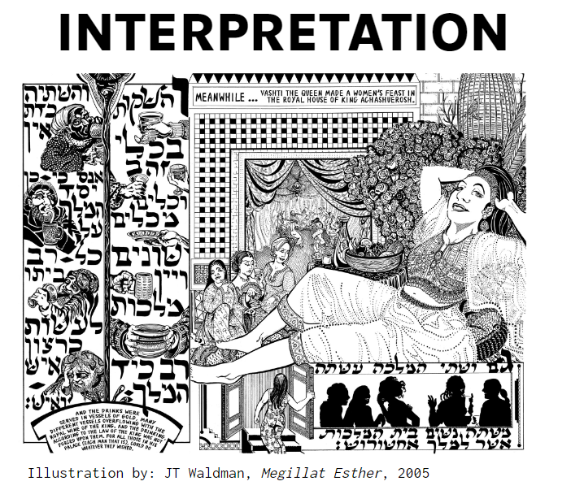
VISUAL EXEGESIS
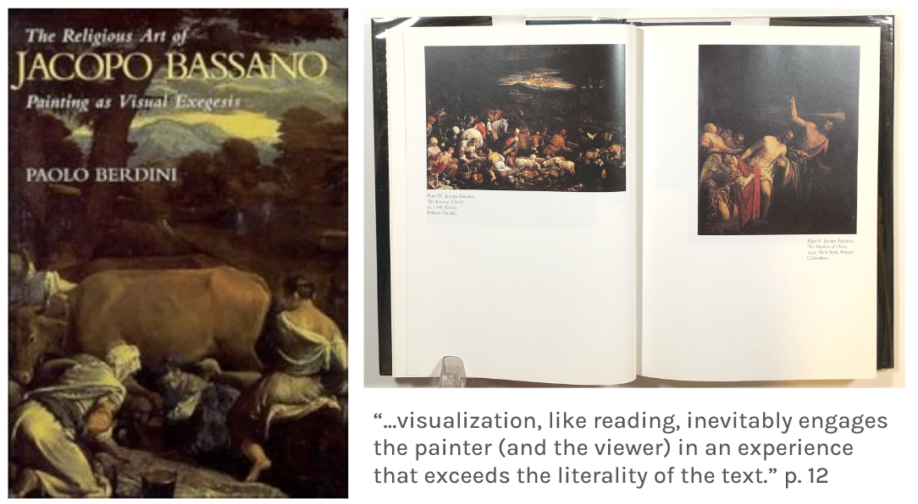
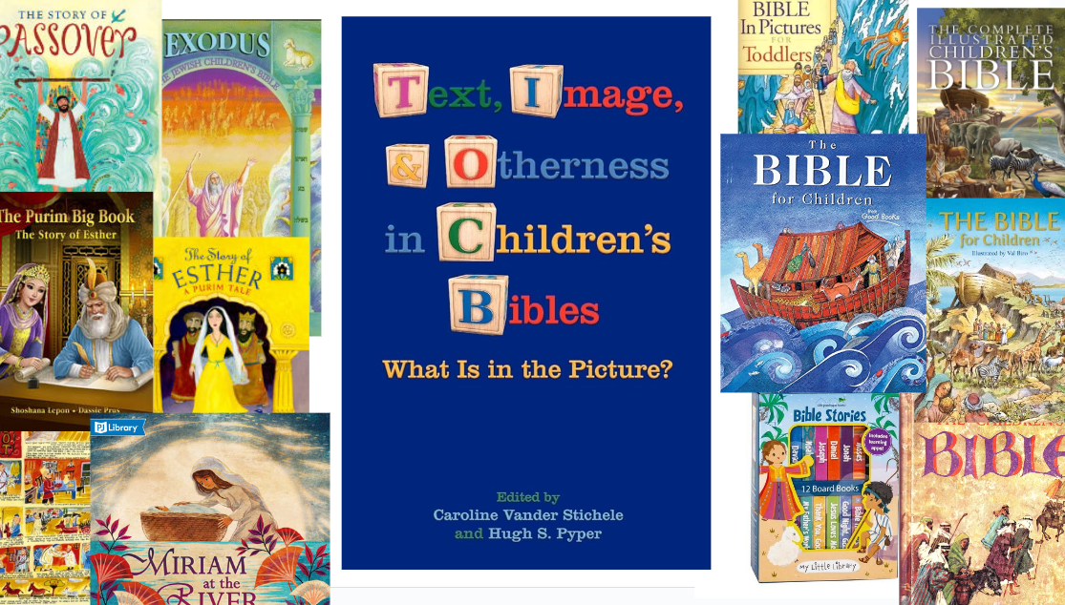
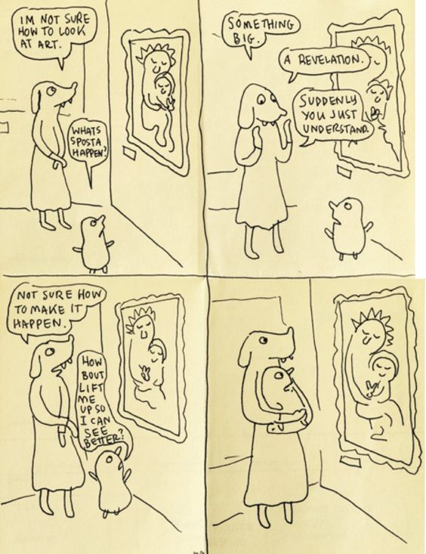
Comic by Lynda Barry
